`

**Final Data Analysis Report for**

**Determine the relationship between VN-Index and VCB on VN stock exchange**

**Version 1.0 approved**

**Instructors: Nguyen Van Sang**

**Prepared by Group 1-IS1602**

**Member**

**Hoang Anh Minh**

**Nguyen Tat Dat**

**Bui Thi Anh**

**Le Huu Phuoc**

31/10/2022

**Table of Contents**

**1 Introduction 3**

**2 Project Goals 3**

**3 Main Finding 3**

**4 Approach 3**

**5 Model Description 5**

**6 Key Points Supported with Data 7**

**7 Model Details 8**

**8 Recommendations 12**

# 1 Introduction

In the process of assessing, implementing, and planning economic policies, stock market information is a crucial channel. It helps managers analyze the "health" of the economy, allowing them to take appropriate macroeconomic management actions. This is an incredibly appealing form for investors; based on stock market information, investors may evaluate company value and market trends and make proper investment choices. Consequently, managers' macroeconomic strategies and investors' capital allocation choices rely heavily on the correct and timely interpretation of stock market information and events. Here, we would like to propose R software for local and international stock market data statistical analysis and index creation.

R is a free, open-source program used for statistical and graph analysis that can be downloaded at r-project.org. R supports the great majority of business analytical approaches, including statistics, machine learning, and optimization techniques. The honors and acclaim received by R are evidence of its efficacy. World-renowned publications and communities, such as The New York Times, Forbes, Intelligent Enterprise, InfoWorld, and The Register. R is a high-level language created for quants, who are specialists in financial analysis.

# 2 Project Goals

* Develop a predictive model to determine The relationship between VN-Index and VCB on VN stock exchange
* Model’s predictive power should be at least as good as customer retention
* Techniques currently being used by the bank
* Models should scale to run on a data set in production environment on monthly basis

# 3 Main Finding

-­ VNI and VCB stock percentage change show that VCB stock have a certain impact into VNI stocks which mean if VCB stock declines then it's not 100% that in the exact same time the VNI stock will decline as well but it will have some decline in the line.

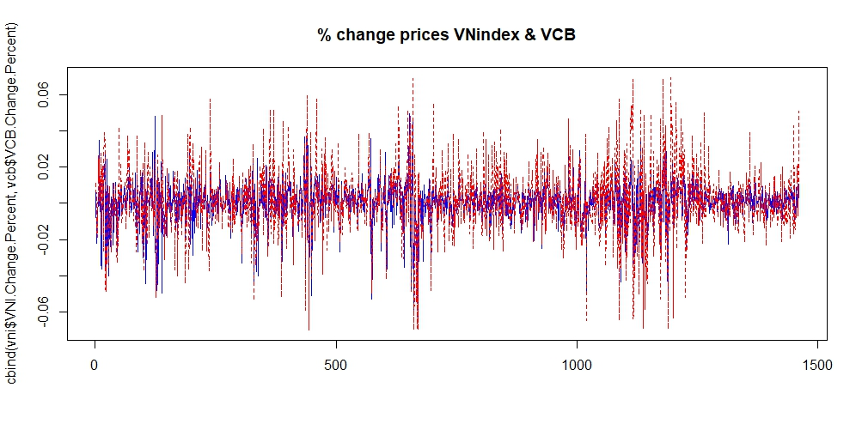

*VNI: blue

*VCB: red

* Understand the relationship between 2 stocks
* Determine when to buy and sell stocks (for reference only), price prediction
* With the correlation chart it shows that the relationship of VCB and VNI are pretty strong.
* **Open prices:**

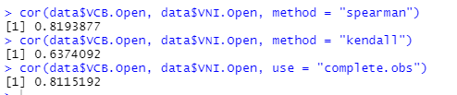

* **Close prices**

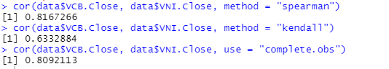

* **% Change:**

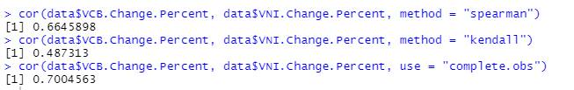

# 4 Approach

* Interviewed a professional in stocks field
* Predictive model to determine the relationship between VN-Index and VCB on VN stock exchange
* Consult some source about rpubs to have more knowledgeable about how to use R in analysis
* Summarize and take data from websites like [investing.com](http://investing.com),...
* Collaborated with IT to identify relevant datasets and assess data quality and availability

# 5 Model Description

* Overview of Basic methodology: find the correlation from the data of the ticker VCB with the ticker of VN Index. Determine it is a strong correlation, covariate and compare with reality
* Model: Linear Regression Model
* Dependent variable: numberic variances, churn
* Scope:
  + 1461 days of VCB’s History Prices from 1/1/2017 to 9/11/2022
  + 1461 days of VNIs History Price from 1/1/2017 to 9/11/2022
  + Compare the attributes of two data sets taken over the same time period: opening price, closing price, %change
* Sampling: Testing: 1461 records

# 6 Key Points Supported with Data

1. **VietcomBank**

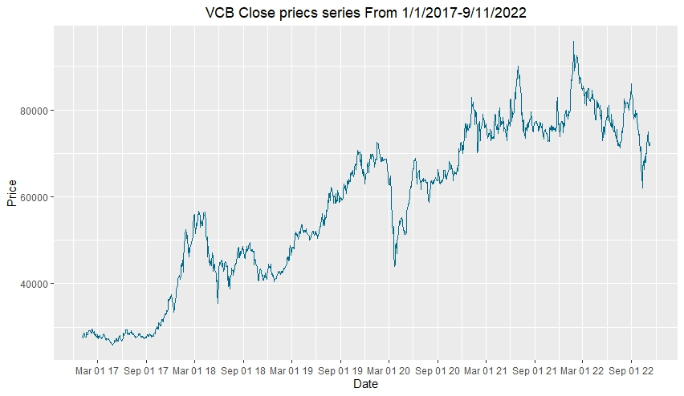

Vietcom Bank Close Prices

Vietcom Bank % change series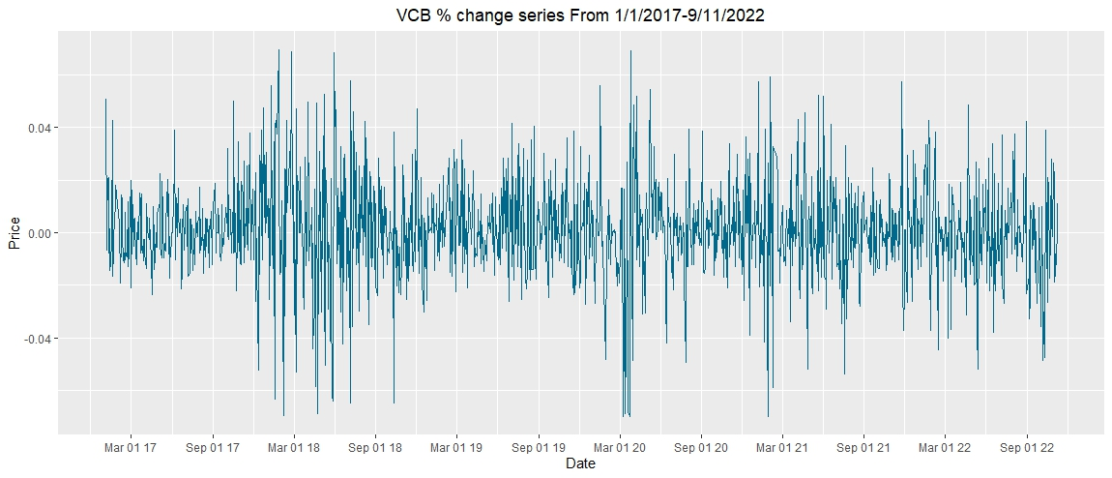

1. **VN Index**

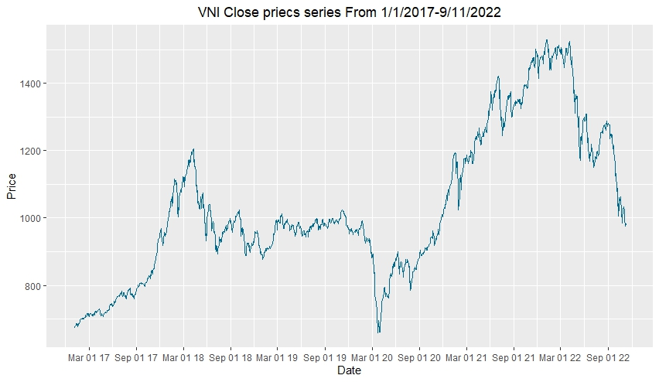

VN Index Close Price

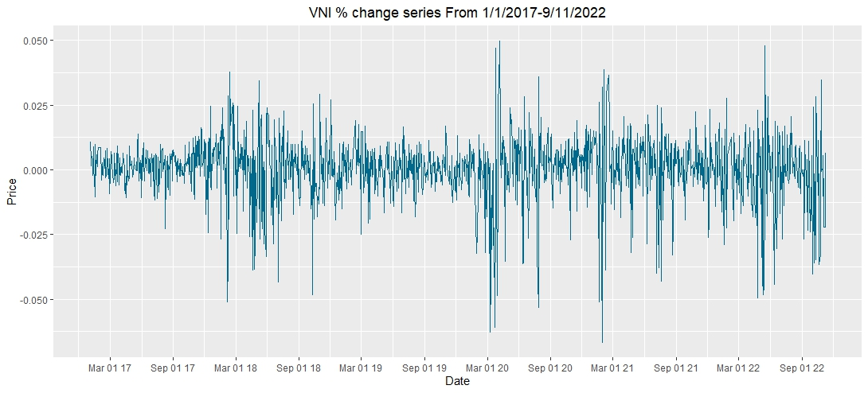

VN Index % change series

# 7 Model Details

1. ***VCB***

* ***% change:***

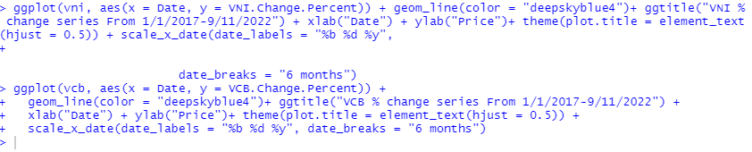

* ***Opening Prices:***

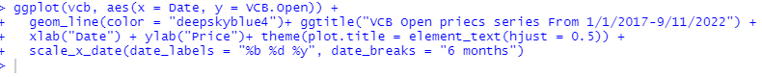

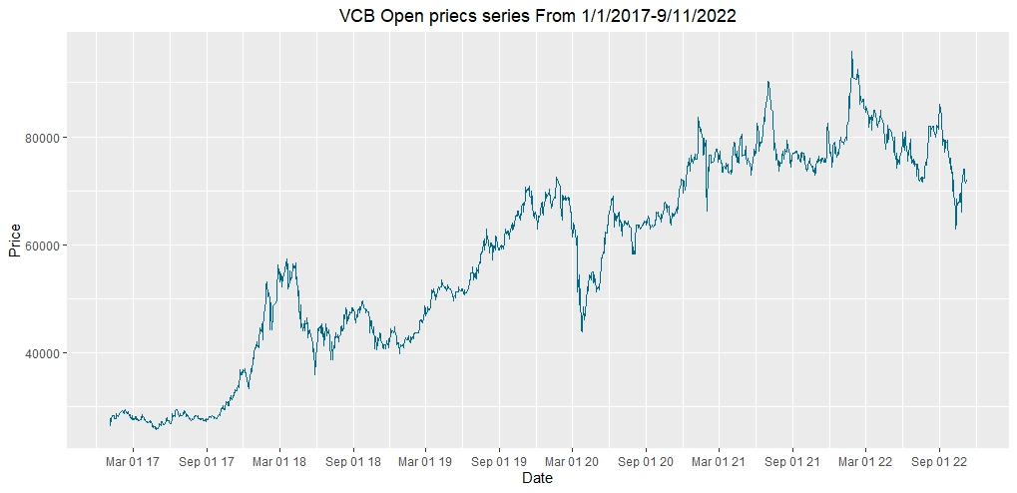

* ***Closing Price:***

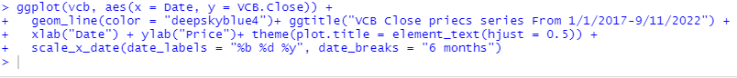



| *MA* | *#calculate three moving averages for the stock prices series,*  *#one with 20 days window and the other with 50 days and 200 days*  *vcb <- xts(vcb[,-1], order.by=vni[,1])*  *vcb_mm20 <- rollmean(vcb[,7], 20, fill = list(NA, NULL, NA), align = "right")*  *vcb_mm50 <- rollmean(vcb[,7], 50, fill = list(NA, NULL, NA), align = "right")*  *vcb_mm200 <- rollmean(vcb[,7], 200, fill = list(NA, NULL, NA), align = "right")*  *vcb$mm20 <- coredata(vcb_mm20)*  *vcb$mm50 <- coredata(vcb_mm50)*  *vcb$mm200 <- coredata(vcb_mm200)*  *#Ploting the prices series and the moving averages for all days since 2022:*  *ggplot(vcb, aes(x = index(vcb))) +*  *geom_line(aes(y = vcb$mm20, color = "MA20")) + ggtitle("VCB prices series") +*  *geom_line(aes(y = vcb$mm50, color = "MA50")) +*  *geom_line(aes(y = vcb$mm200, color = "MA200")) + xlab("Date") + ylab("Price") +*  *theme(plot.title = element_text(hjust = 0.5), panel.border = element_blank()) +*  *scale_x_date(date_labels = "%b %d %y", date_breaks = "6 months") +*  *scale_colour_manual("Series", values=c("MA20"="deepskyblue4", "MA50"="purple", "MA200"="darkorange"))* | *Moving Averages - the smoother the line, the less volatile*  *=> smoother the line* |
| --- | --- | --- |

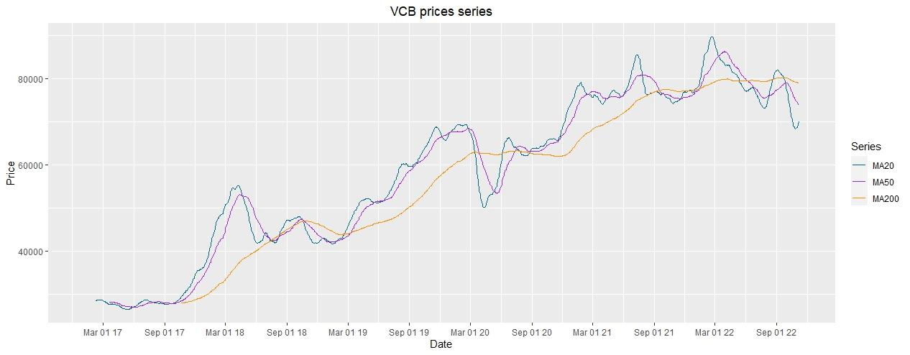

| *The volatility*  *(~20%low volatility*  *>40% is high volatility)* | *#volatility*  *>volatility=sqrt(252)*sqrt(var(log(vcbOp[2:n]/vcbOp[1:n-1])))*  *>volatility*  *[1] 0.2948841* | *Average volatility (~29,5%)* |
| --- | --- | --- |

1. ***VNI***

* ***% change***

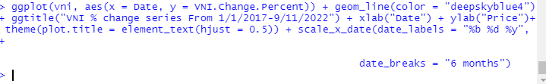



* ***Closing Price:***

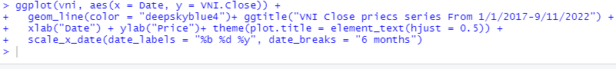



* ***Opening Price:***



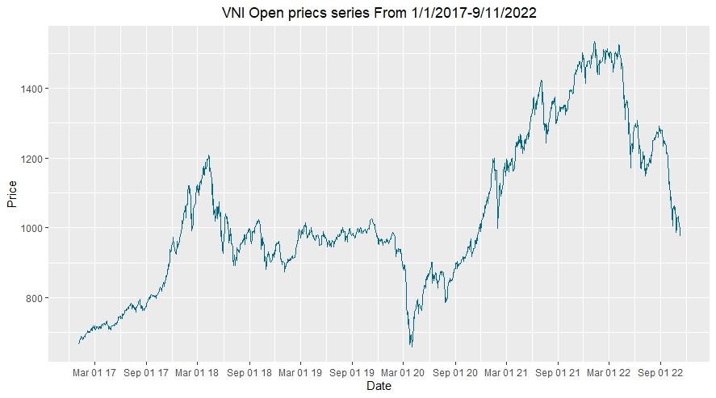

| *MA* | *#calculate three moving averages for the stock prices series,*  *#one with 20 days window and the other with 50 days and 200 days*  *vni <- xts(vni[,-1], order.by=vni[,1])*  *vni_mm20 <- rollmean(vni[,7], 20, fill = list(NA, NULL, NA), align = "right")*  *vni_mm50 <- rollmean(vni[,7], 50, fill = list(NA, NULL, NA), align = "right")*  *vni_mm200 <- rollmean(vni[,7], 200, fill = list(NA, NULL, NA), align = "right")*  *vni$mm20 <- coredata(vni_mm20)*  *vni$mm50 <- coredata(vni_mm50)*  *vni$mm200 <- coredata(vni_mm200)*  *#Ploting the prices series and the moving averages for all days since 2022:*  *ggplot(vni, aes(x = index(vni))) +*  *geom_line(aes(y = vni$mm20, color = "MA20")) + ggtitle("VNI prices series") +*  *geom_line(aes(y = vni$mm50, color = "MA50")) +*  *geom_line(aes(y = vni$mm200, color = "MA200")) + xlab("Date") + ylab("Price") +*  *theme(plot.title = element_text(hjust = 0.5), panel.border = element_blank()) +*  *scale_x_date(date_labels = "%b %d %y", date_breaks = "6 months") +*  *scale_colour_manual("Series", values=c("MA20"="deepskyblue4", "MA50"="purple", "MA200"="darkorange"))* | [*Picture*](https://drive.google.com/file/d/1OucDVgqZel2BhVMHnT1wRASEwri8Ha3O/view?usp=sharing)  *Moving Averages - the smoother the line, the less volatile*  *=> smoother the line* |
| --- | --- | --- |

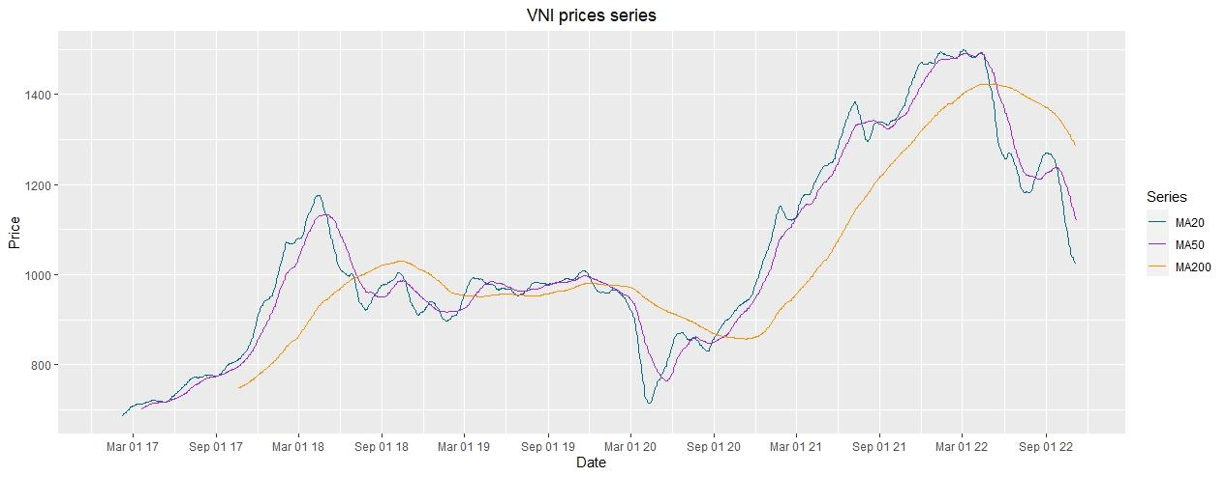

| *Volatility*  *(~20% low volatility*  *>40% is high volatility)* | *attach(vni)*  *vniOp = rev(vni$Open)*  *n=length(vcbOp)*  *#bien dong*  *volatility=sqrt(252)*sqrt(var(log(vniOp[2:n]/vniOp[1:n-1])))*  *volatility*  *[1] 0.2323556* | *Average volatility (~23,23%)* |
| --- | --- | --- |

1. **Relationship between stock ticker of Joint Stock Commercial Bank for Foreign Trade of Vietnam (VCB) and VN index (VNI )**

* **Open prices:**

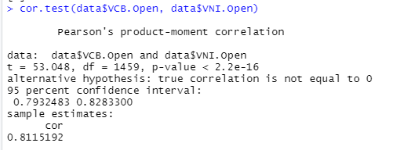

* Test hypothesis:
  + H0: No correlation (correlation coefficient = 0)
  + Ha: There is correlation
* Test method: Pearson
* => Result: There is correlation, the correlation coefficient is positive
* => Opening prices of VCB and VNI both increased/decreased

Similarly, when we use other testing methods such as kendall (rank), spreaman (rank) all give results of strong correlation or correlation.

**

* **Close prices**

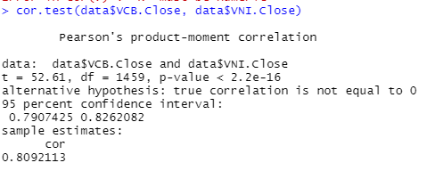

- Test hypothesis:

* + H0: No correlation (correlation coefficient = 0)
  + Ha: There is correlation
* Test method: Pearson
* => Result: There is correlation, the correlation coefficient is positive
* => Closing prices of VCB and VNI both increased/decreased

Similarly, when we use other testing methods such as kendall (rank), spreaman (rank) all give results of strong correlation or correlation.

**

* **% Change:**

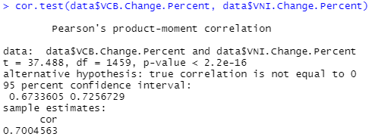

* Test hypothesis:
  + H0: No correlation (correlation coefficient = 0)
  + Ha: There is correlation
* Test method: Pearson
* => Result: There is correlation, the correlation coefficient is positive
* => % changing of VCB and VNI both increased/decreased

Similarly, when we use other testing methods such as kendall (rank), spreaman (rank) all give results of strong correlation or correlation.

**

| *Name* | *Code* |
| --- | --- |
| *% change* | *matplot(cbind(vni$VNI.Change.Percent,vcb$VCB.Change.Percent),type="l",col=c("blue","red") ,main="% change prices VNindex & VCB")* |



* Correlation:

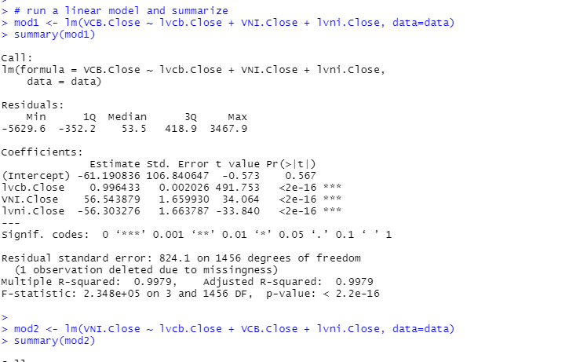

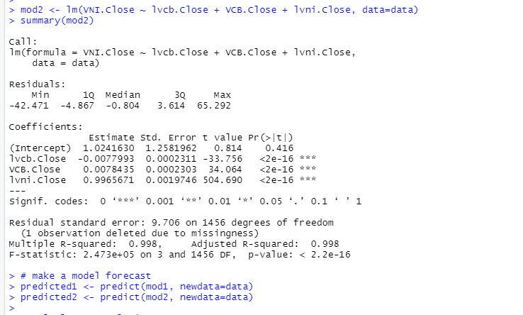

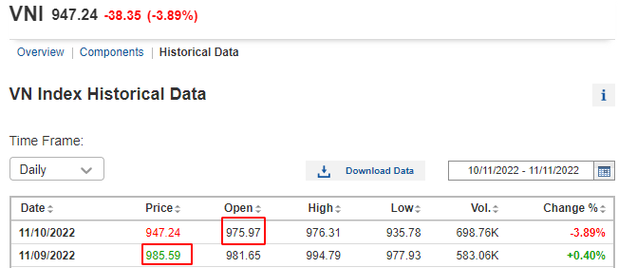

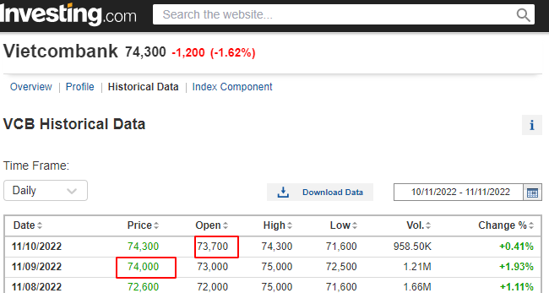

| *Correlation graph* | *stocks <- merge(vcb, vni)*  *corstocks <- as.data.frame(stocks[,c(1,4,5,7,8,11,12,14)])*  *corstocks %>% head()*  *M <- cor(corstocks)*  *corrplot(M, method = "circle")* |
| --- | --- |

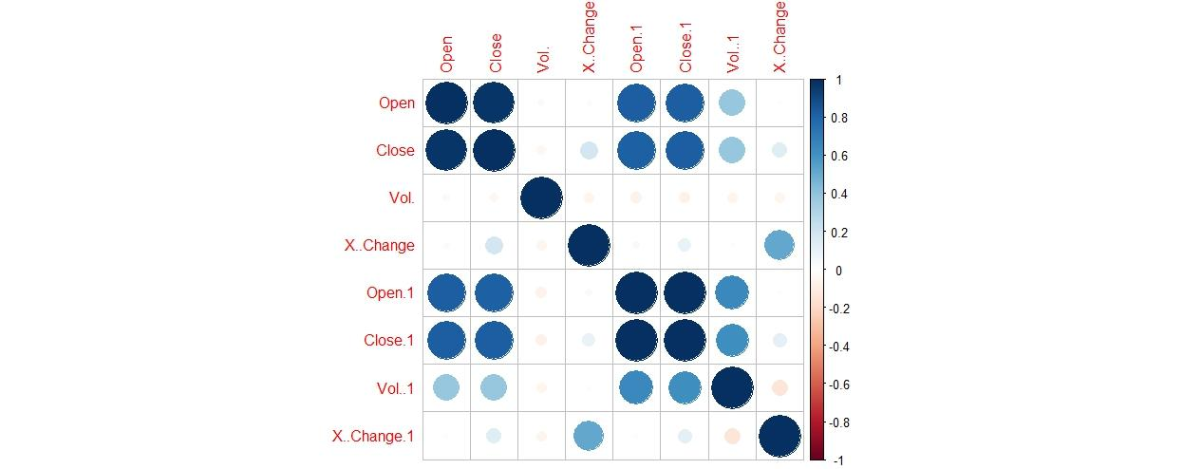

1. **Compare**



Compare of % change

* We us these Chart to compare that we can see the higher the volume of VCB, the more it will affect the Vn_index

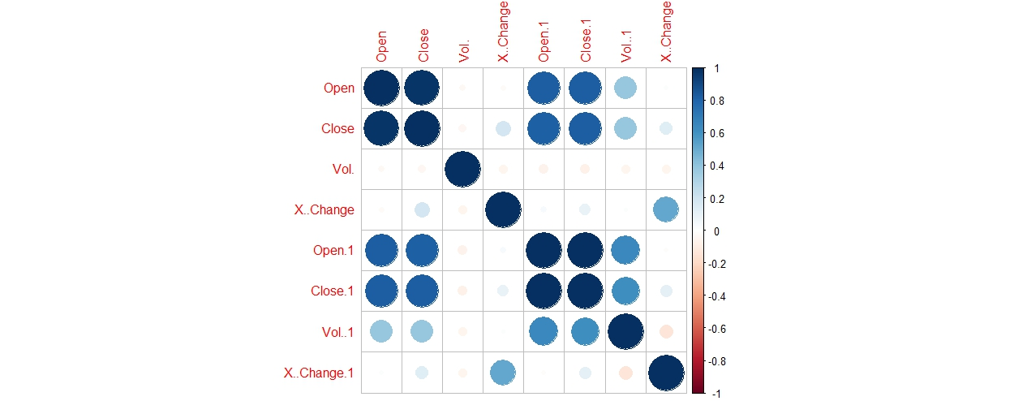

Correlation Chart

The correlation of both VCB and VN_Index is similar. There for VCB’s index has affection for VN_Index

# 8 Recommendations

The move by Vietnam's biggest bank by market value comes as diplomatic ties between Communist Vietnam and former war enemy United States are on the rise and is part of a push to expand internationally as it aims for a place among the world's top 300 banking and financial groups.

Vietcombank itself is implementing many projects such as real estate, corporate financial consulting, securities depository, currency brokerage, guarantee, etc. Each field has been reaping the benefits. good value for the organization.

At the same time, in the banking sector, Vietcombank is always at the forefront of product and service quality, constantly improving quality to best serve customers. Of course, all activities comply with applicable laws, regulations in banking and other permitted related activities.

It can be said that VCB stock will grow stronger in the future. Of course, if the market has big fluctuations affecting the bank, believe that this organization will still perform well, overcome difficulties and move forward. This Vietcombank stock investor will feel safer and more secure, not afraid of the issuer going bankrupt or disappearing from the market.